Determination of freezing point depression and eutectic point of p-dichlorobenzene and naphthalene mixture

Nathan Gillispie. Lab Partners: Chloe Jones, Brian Kellogg

Date of experiment: October 12, 2022

Introduction

The melting point of a pure substance is decreased by impurities given by the equation:

ΔT=Kfm

(1)

where Kf is the cryoscopic constant and m is the molality of solute. Note that the identity of the solute is not required. ΔT is how much the melting point is lowered from its pure value. The cryoscopic constant is typically tabulated but can be calculated using the following formula:

$$K_{f}=\frac{MR{T_{f}}^{2}}{{ΔH}_{fus}}$$

(2)

M is the molar mass of the solvent in kg/mol, Tf is the freezing point of the pure solvent, R is the gas constant in J/mol and ΔHfusis the enthalpy of fusion in J/mol. This lab will allow us to calculate the cryogenic constant from eq. 1 and calculate the enthalpy of fusion from eq. 2 which can be compared to literature values. This will also allow us to construct a binary phase diagram which has the general form found below.

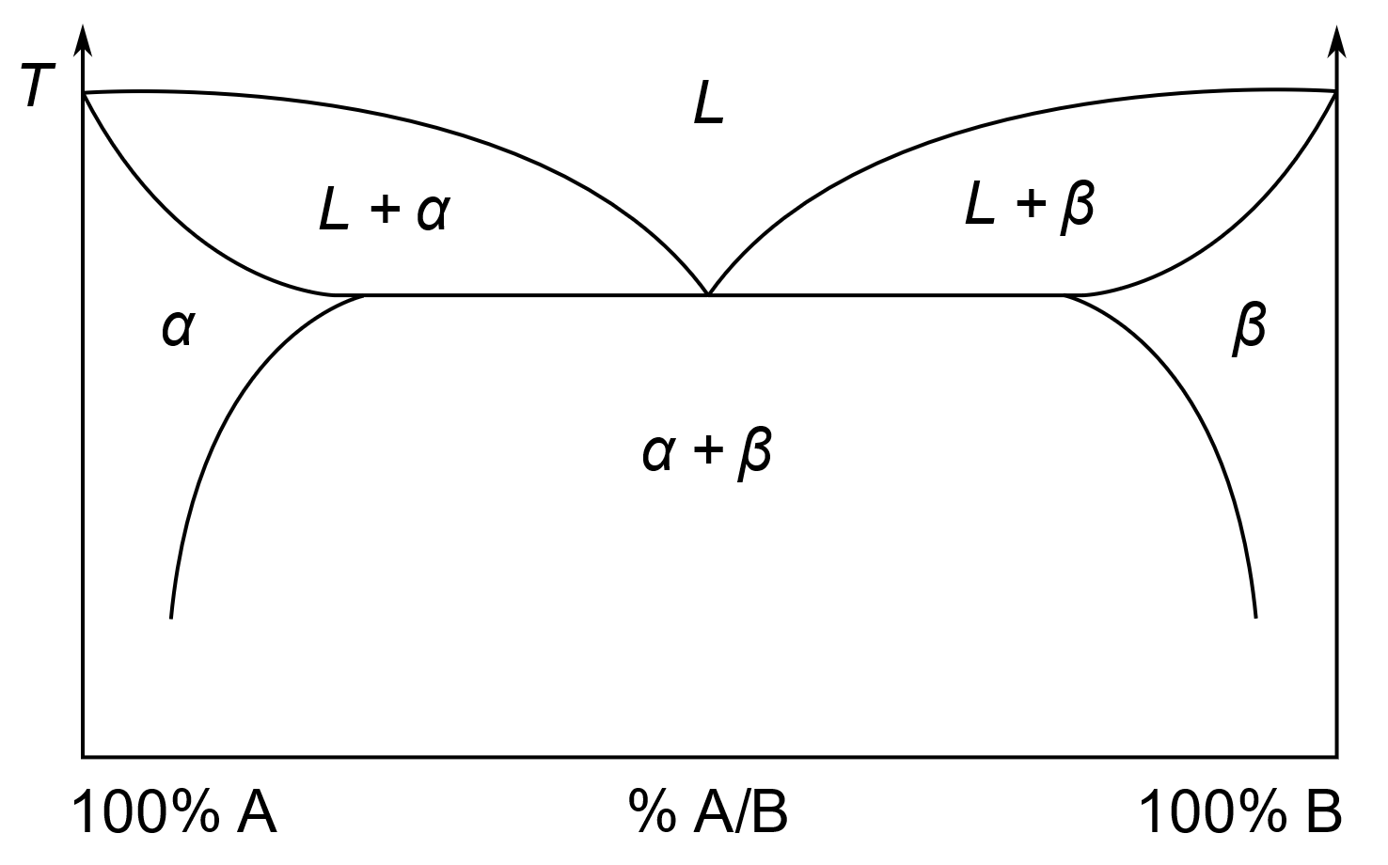

Figure 1: General binary phase diagram. β is solid B, α is solid A and L is a liquid mixture of both A and B.

Methods

Prior to the experiment, a sand bath was prepared and a digital thermometer was placed in a test tube. Naphthalene was chosen as the solvent for the group. Five grams of solvent was placed in a test tube. The solvent was melted by holding the test tube in a flask of boiling water. When the solvent had reached about 95°C (15°C above its melting point), it was removed from the hot water bath and quickly placed in the sand bath, a timer started and a member of the group recorded the temperatures every two seconds. The test tube was continually stirred. Once the solvent had fully solidified, about 0.5 grams of the paradichlorobenzene, or solute, was added. This mixture was melted using the same process. Once it had reached about 95°C, the cooling procedure was repeated. The addition procedure was repeated for another two 0.5 gram additions for a total of four measurements. The mixture in the test tube was melted and placed in the appropriate container.

Data and Results

**Table 1:** Collected and calculated data. The first four trials were obtained by the author and their partners while the last four sets were obtained from a separate group that did not include all relevant calculations. Uncertainties of mole fraction were estimated from similar measurements.

|  |  |  |  |  |  |
| --- | --- | --- | --- | --- | --- |
|  | Melting Temperature (K) | Mole Fraction of p-dichlorobenzene | ΔT relative to pure solvent (K) | ΔHfus (J/mol) | Kf (Km) |
| Trial 1, ours | 354.0±0.6 | 0.00000 | N/A | N/A | N/A |
| Trial 2, ours | 348.3±0.4 | 0.08252±1e-5 | 5.62±0.01 | 16100±200 | 8.01±0.01 |
| Trial 3, ours | 346±5 | 0.15036±1e-5 | 7.80±0.01 | 21200±300 | 5.649±0.007 |
| Trial 4, ours | 341.45±0.73 | 0.20813±1e-5 | 12.50±0.01 | 20000±1000 | 6.096±0.005 |
| Trial 1, theirs | 311.12±0.01 | 0.7440±0.0001 |  |  |  |
| Trial 2, theirs | 316.89±0.01 | 0.8134±0.0001 |  |  |  |
| Trial 3, theirs | 321.04±0.01 | 0.8971±0.0001 |  |  |  |
| Trial 4, theirs | 327.75±0.01 | 1.0000±0.0001 | N/A | N/A | N/A |
| Average | - | - | - | 19000±1000 |  |

Figure 2: Temperature over mole fraction. This graph allows us to estimate the eutectic point.

Plot 1: Pure substance freezing. This plot shows the pure naphthalene freezing over time.

Plot 2: Mixture freezing. This plot shows the freezing of naphthalene after the first addition of p-dichlorobenzene.

Plot 3: Mixture freezing. This plot shows the freezing of naphthalene after the second addition of p-dichlorobenzene.

Plot 4: Mixture freezing. This plot shows the freezing of naphthalene after the third addition of p-dichlorobenzene.

Plot 5: Uncertainty calculation for trial 4. This plot is the best guess melting temperature.

Plot 6: Uncertainty calculation for trial 4. This attempts to minimize the melting temperature using different guesses.

The initial amount of naphthalene measured was 5.0156±0.0001g. The first addition added 0.5174±0.0001g of paradichlorobenzene. Calculation of mole fraction with uncertainty is shown in the appendix as figure 3.

Uncertainties for each melting point were calculated using worst case scenario. The freezing point is calculated using a linear fit of the best two lines before and after freezing, this is demonstrated in plot 5. Two other pairs of lines were selected as alternate guesses that a reasonable person could also pick to calculate the melting point with, this was demonstrated in plot 6. The melting points were compared with the difference becoming the uncertainty for the best fit. An example calculation is shown in the appendix as figure 4.

The uncertainties in freezing point depression temperature were propagated using relative uncertainties. The cryoscopic constant was calculated according to eq. 1 with worst case scenario uncertainty. An example calculation is shown in the appendix as figure 5.

The enthalpy of fusion was calculated according to eq. 2 and the uncertainties were propagated using worst case scenario. An example calculation is shown in the appendix as figure 6.

The uncertainty in the average enthalpy of fusion value was calculated with quadrature from the enthalpy of fusion values found in table 1.

The average literature value for the enthalpy of fusion of naphthalene was 18900±700J/mol.2 Using the two standard error criterion we observe the 18900J/mol falls within the average enthalpy of fusion in table 1 as 20000±1000 J/mol

As seen in figure 2, we can estimate the eutectic temperature of the mixture between paradichlorobenzene and naphthalene at x of p-dichlorobenzene=0.45. This extrapolation was performed using a cubic polynomial.

Conclusion

As predicted by eq. 1, all our freezing points were continually lowered as we added solute. This is proven by the consistent value achieved for the cryogenic constant, the percent standard error was 19% showing the linear nature of eq. 1. It is difficult to estimate the eutectic temperature from figure 1 as the fit is cubic and the falloff is much steeper than you might expect.

The enthalpy of fusion was calculated and we observed a relative uncertainty of 5%, the relative uncertainty of the averaged literature values was 3.7% indicating the inconsistency in our measured values. Because of this large uncertainty, we were still able to find that our values agreed with the literature within two standard error. Our enthalpy of fusion was calculated to be 20000±1000J/mol and the literature values were averaged to 18900J/mol with a standard deviation of 700J/mol.

Safety

Naphthalene is combustible and may be explosive with air when exposed to heat. It is carcinogenic and toxic on oral ingestion. It is extremely toxic and persists in aquatic life, care should be taken to clean out all test tubes thoroughly before washing test tubes with water.3

References

(1) *Naphthalene | C10H8 - PubChem*. https://pubchem.ncbi.nlm.nih.gov/compound/naphthalene (accessed 2022-10-28).

(2) Naphthalene. *NIST Database*. https://webbook.nist.gov/cgi/cbook.cgi?ID=C91203&Mask=4

(3) *Naphthalene MSDS - 820846 - MilliporeSigma*. https://www.emdmillipore.com/US/en/product/msds/MDA_CHEM-820846?ReferrerURL=https%3A%2F%2Fduckduckgo.com%2F&bd=1 (accessed 2022-10-28).

Appendix

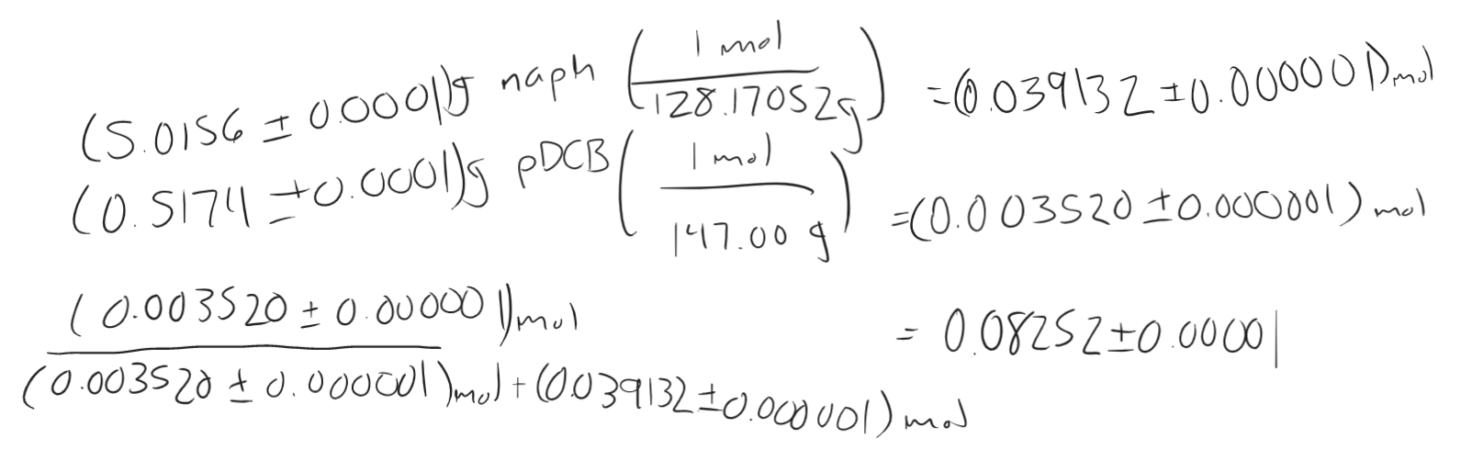

Figure 3: Calculation and uncertainty of mole fraction of trial 4.

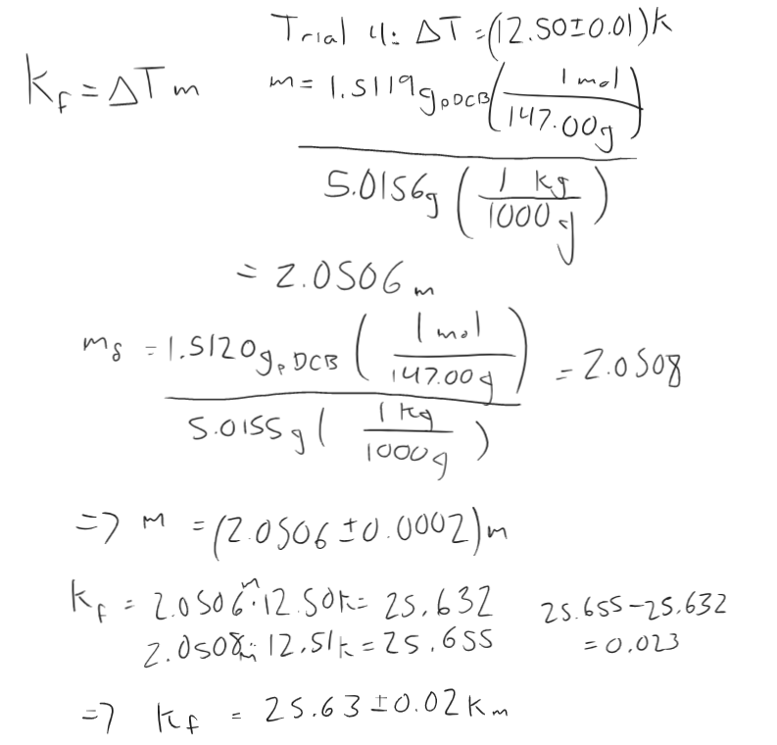

Figure 4: Uncertainty and calculation of cryogenic constant/

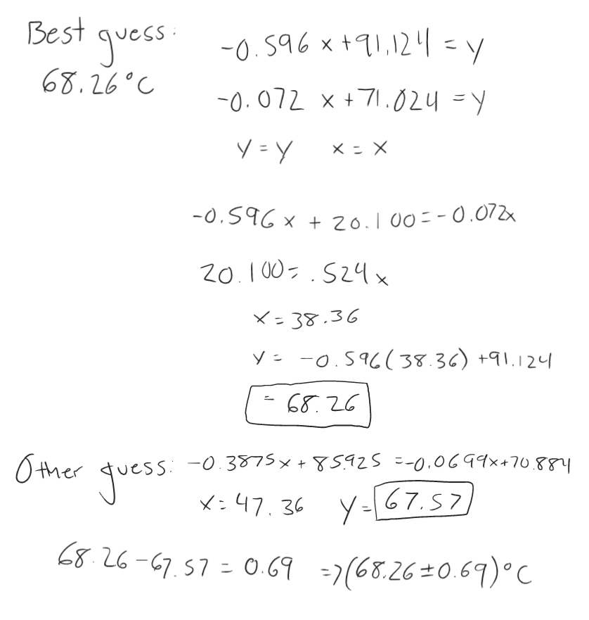

Figure 5: Uncertainty calculation for melting temperature.

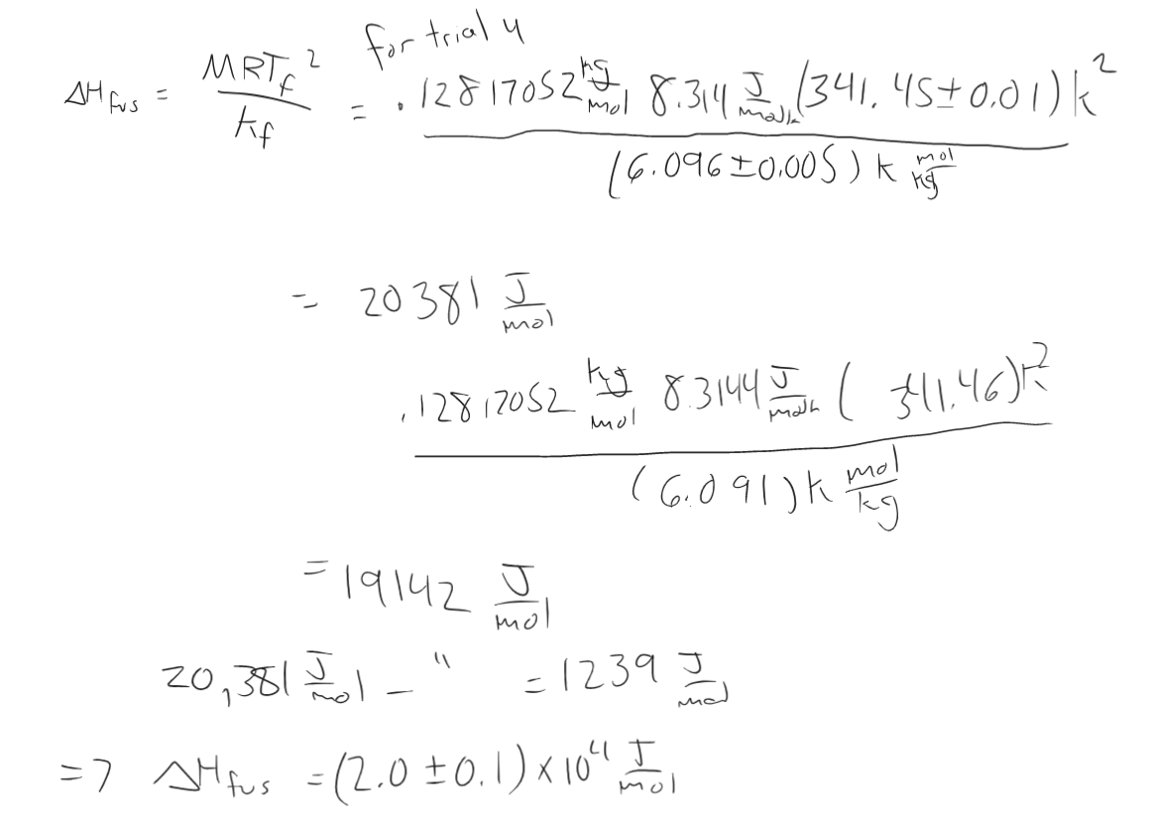

Figure 6: Uncertainty calculation for enthalpy of fusion for trial 4